**Department of Rural and Community Development**

**Local Enhancement Programme 2025**

**Applications under the €1m Current Funding**

**NOTE: Closing Date: 4.00 p.m. Friday, 7th March 2025**

**INCOMPLETE APPLICATIONS WILL BE RETURNED**

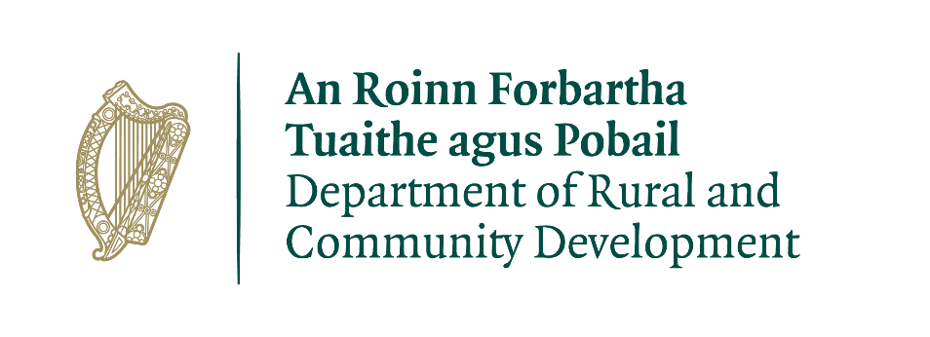 

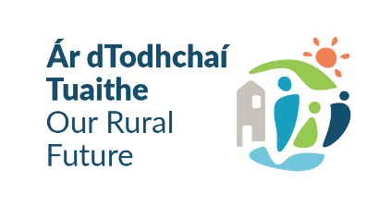

**FOR OFFICE USE ONLY**

Date Received:

Reference Number:

LCDC recommendation:

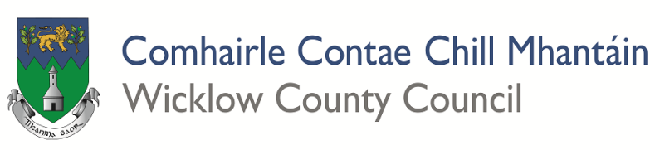

GROUP /ORGANISATION NAME

**ALL APPLICATIONS ARE TO BE RETURNED TO:**

**LEP 2025, Social Development (Housing & Community),**

**Wicklow County Council, Whitegates, Wicklow Town, A67 FW96.**

**OR SCANNED APPLICATIONS TO BE EMAILED TO:**

LEP@wicklowcoco.ie

**By 4.00 p.m. on Friday, 7th March 2025**

**CLOSING DATE WILL BE STRICTLY ADHERED TO.**

**ONLY FULLY COMPLETED APPLICATIONS WILL BE ACCEPTED. INCOMPLETE APPLICATIONS WILL BE RETURNED TO APPLICANT**

**Please read and make yourself familiar with the Application Guidelines for the ‘Local**

**Please read and make yourself familiar with the Application Guidelines for the ‘Local Enhancement Programme 2025’ before completing this form.**

**Department of Rural and Community Development**

**Local Enhancement Programme 2025**

**€ 1m Current Funding**

The Department of Rural and Community Development (“the Department”) has allocated funding of €1 million to support groups/organisations across Ireland.

This is a reserved fund under the Local Enhancement Programme 2025[1]. The application process is being administered by Local Community Development Committees (LCDCs).

Applications for this funding can be made on this application form. Community Groups/Organisations are eligible to apply, once they meet the LCDC’s qualifying criteria.

It envisaged that this funding would, in general, be allocated in a relatively equal manner across Community Groups/Organisations that submit valid applications.

##### TERMS AND CONDITIONS

* The €1million funding under the Local Enhancement Programme will support Community groups/organisations particularly in disadvantaged areas, to supporttheir non-pay running costs for example energy costs/bills (electricity costs, refuse charges, heating charges), rental/lease costs, insurance bills.
* This is a **current** funding scheme. The scheme does not provide funding for capital works, equipment etc. this can be applied for under the capital allocation of the funding.
* The information supplied by the applicant Community Group/Organisation must be accurate and complete.
* Inaccurate or incomplete information may lead to disqualification and/or the repayment of any grant made.
* All information provided in respect of the application for a grant will be held electronically. The Department reserves the right to publish a list of all grants awarded on its website.
* The Freedom of Information Act applies to all records held by the Department and Local Authorities, including applications received and any additional correspondence related to the application.
* The application must be signed by the Chairperson, Secretary or Treasurer of the organisation making the application.
* It is the responsibility of each organisation to ensure that it has proper procedures and policies in place including appropriate insurance where relevant.
* Applications must be on the application form for 2025.
* Evidence of expenditure, receipts /invoices must be retained and provided to the LCDC, the Department of Rural and Community Development, the relevant local authority or any agent acting on their behalf if requested.
* Grant monies must be expended and drawn down from the LCDC by 31st December 2025.
* The Department of Rural and Community Development’s contribution must be publicly acknowledged in all materials associated with the purpose of the grant.
* Generally, no third party or intermediary applications will be considered.
* Late applications will not be considered.
* To ensure appropriate monitoring and governance, the Department is stating that only operating/running costs related to this period are eligible - **1st June 2024 to 30th May 2025**
* Applications by post should use the correct value of postage stamps and allow sufficient time to ensure delivery not later than the closing date of **Friday, 7th March 2025.** Claims that any application form has been lost or delayed in the post will not be considered, unless applicants have a Post Office Certificate of Posting in support of such claims.
* Breaches of the terms and conditions of the grants scheme may result in sanctions including disbarment from future grant applications.
* Please ensure the application form is completed in full. Incomplete applications will not be considered for funding.
* In order to process your application, it may be necessary for Wicklow County Council to collect personal data from you. Such information will be processed in line with the Local Authority’s privacy statement which is available to view on [www.wicklow.ie/LivingYour-Council/Governance/Privacy-Policy](http://www.wicklow.ie/LivingYour-Council/Governance/Privacy-Policy).

**All questions on this form must be answered. Please write your answers clearly in block letters.**

## SECTION 1 – YOUR ORGANISATION

|  |  |
| --- | --- |
| **Name of Group/Organisation** |  |
| Address |  |
| Eircode |  |
| **Municipal District (Circle as Appropriate)** | Arklow | Baltinglass | Bray | Greystones | Wicklow | Countywide |
| Contact name |  |
| Role in Group |  |
| Telephone number |  |
| E-mail |  |
| Website |  |
| Alternative Contact name |  |
| Alternative Telephone number |  |
| Alternative E-mail |  |

**Successful applications for funding under this programme will only be paid to the applicant organisation’s Bank Account. Please ensure you have your Bank Account details to hand if your application is successful.**

Charitable Status Number (if applicable): ___________________________________________

Tax Reference Number (if applicable): _____________________________________________

Tax Clearance Access Number (if applicable): _______________________________________

**SECTION 2 – Description of Activities**

Please provide a description of your Organisation/Group including information on the number of members, the organisational structure of your group, your group’s aims, whether there is any criteria for membership, the main focus of the activities of your group, etc.

**SECTION 3 – Project Details**

What will the funding be used for?

**­­­­­­­­­­­­­­­­­­­­­­­­­­­**

|  |  |  |
| --- | --- | --- |
| Amount being applied for: | € | |
| Is this amount the partial or total cost of the purchase of non-pay running cost(s) where support is being applied for: | Partial | Total |
| If partial, please give the estimated total cost: | € | |

Billing period (if applicable) Dates:

**Important note:** Please include supporting documentation, please contact [LEP@wicklowcoco.ie](mailto:LEP@wicklowcoco.ie) for information on the required supporting documentation.

Please state how your group/organisation proposes to acknowledge the Department, LA or LCDC.

**Note:** Depending on the amount being applied for, this could be as simple as including an acknowledgement on notices/signs, or in any newsletters that are being produced locally.

­­­­­­­­­­­­­­­­­­­­­­

­­­­­­­­­­­­­­­­­­­­­­

**SECTION 4 - DECLARATION**

**PLEASE NOTE BEFORE SUBMITTING:**

**ONLY FULLY COMPLETED APPLICATIONS WILL BE ACCEPTED.**

**INCOMPLETE APPLICATIONS WILL NOT BE CONSIDERED**

* I declare that the information given in this form is correct.
* I confirm I have read and fully understand the Terms and Conditions of this Programme (see page 2-3 of this form).
* I confirm that this grant application is submitted in acceptance of and compliance with the Terms and Conditions.

* I confirm that the group/organisation does not have the funding to cover the costs without this grant aid or alternatively that with the grant the Group will now cover a larger cost which they otherwise would not be able to afford.
* I confirm that the applicant Group is tax compliant (if tax registered).

|  |  |
| --- | --- |
| **Name in block capitals (on behalf group/organisation):** |  |
| **Signature:**  **(Please note a typed signature will not suffice)** |  |
| **Position held (block capitals):** |  |
| **Date:** |  |

1. The Department operates the Local Enhancement Programme through the Local Community Development Committees (LCDCs). It is a grant programme that provides funding to enhance facilities in disadvantaged areas. The Department is committed to funding of €7 million for this programme. The €1 million current funding is part of the €7 million funding.